Mastering Your Money — The Art of Budgeting
Budgeting isn’t about saying no, it’s about learning how to say yes to what truly matters.
It’s not restriction, it’s direction, the skill that turns income into progress.
You’ve learned how money works.
Now, it’s time to learn how to make it work for you.
Chapter 1: Why Budgeting Matters
Most of us think we know where our money goes — until we start tracking it.
A coffee here, a delivery there, a weekend out… and suddenly, the money’s gone before the month is.
Budgeting is what gives your money clarity.
It turns your spending from random into intentional.
It’s the map that connects your goals with your daily choices.
When you budget, you’re not limiting yourself, you’re choosing what’s worth your energy and effort.
“You can’t grow what you don’t track.”
Budgeting is the foundation of wealth because it builds awareness and awareness builds control.
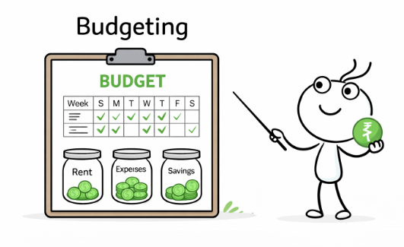
Chapter 2: Track Before You Tweak
Before you can improve your finances, you need to understand them.
Start by tracking your spending for at least one full month.
Step 1: List every source of income — your salary, side hustle, freelance gigs, or even rent earned.
Step 2: Note down your expenses — split them into categories like needs, wants, savings, and debt repayments.
Step 3: Review. Where does most of your money go? What could you cut or optimize?
You can use a budgeting tool or simply Excel/Google Sheets(Our preference) — whatever helps you stay consistent and honest.
Don’t rush to fix everything right away.
Tracking is about observation, not judgment.
You can’t fix leaks until you know where they are.
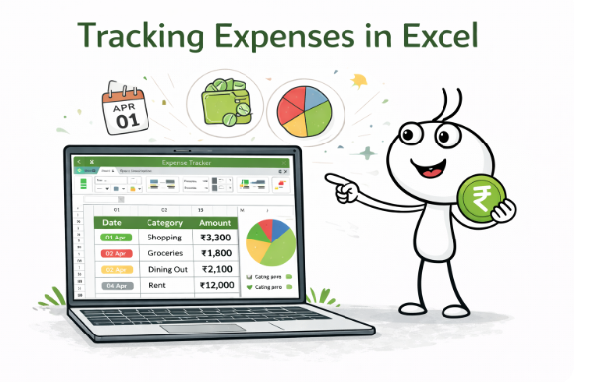

Chapter 3: The 50-30-20 Rule (and Beyond)
This simple rule is a timeless favorite because it’s easy, balanced, and effective.
- 50% — Needs: Essentials like rent, groceries, utilities, transport.
- 30% — Wants: Dining out, shopping, hobbies, travel.
- 20% — Savings & Investments: Emergency fund, SIPs, or long-term goals.
Start here and then adapt it as you grow.
If you’re saving for a big goal, go 40-30-30.
If you’re early in your career and want flexibility, maybe 60-25-15.
There’s no perfect ratio, just the one that helps you stay consistent.
Budgeting isn’t about strict rules, it’s about balance with purpose.
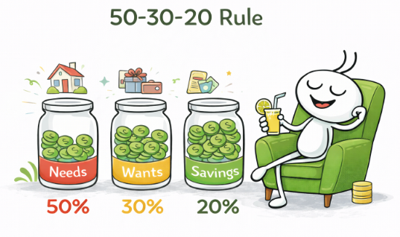
Chapter 4: Smart Saving & Spending Hacks
Money management isn’t only about cutting down, it’s about making your spending smarter.
Here are some habits that actually work:
- Automate savings — set them up to transfer on salary day.
- Sleep on impulse buys — wait 24 hours before you spend on anything non-essential.
- Track subscriptions — cancel the ones you don’t use regularly.
- Use the envelope method (digitally) — separate “fun money” from essentials.
- Have a guilt-free fund — it keeps you consistent and sane.
Spend on what you love. Save on what doesn’t matter.
When you’re intentional, every expense starts to feel like an investment in your own priorities.
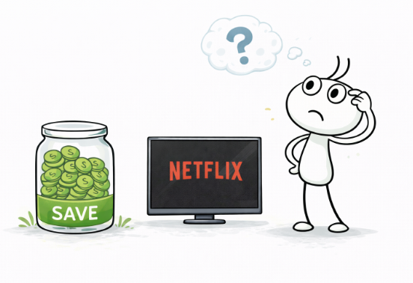

Chapter 5: Build Your Emergency Fund — Your First Line of Defense
Before you start chasing returns, make sure you’re protected.
Investing without an emergency fund is like driving fast without brakes.
Life’s surprises — job loss, medical expenses, home or car repairs, can arrive unannounced.
An emergency fund gives you the financial breathing room to handle them calmly, without touching your investments or going into debt.

How Much Should You Save?
Aim to set aside 3–6 months of your monthly expenses.
If you’re self-employed, freelancing, or supporting dependents, build a larger cushion — around 6–9 months of expenses.
This might sound like a big goal, but remember, it’s your financial safety net. Build it aggressively before you focus on investing. Every rupee here buys you peace of mind.

Where to Park It
Your emergency fund needs to be safe, stable, and quickly accessible , but still earn better returns than a regular savings account.
Here’s where you can keep it:
- Debt Funds (Liquid or Ultra Short-Term Funds): Ideal for slightly better returns (around 6–7%) with easy access in 1–2 days.
- High-Interest Savings Accounts: Good for partial liquidity, keep 1–2 months’ worth here for instant access.
- Short-Term FDs (1–3 months): Optional for those who prefer fixed returns, but less flexible than debt funds.
Avoid putting this money in stocks, mutual funds, or any high-risk investment.
Your goal here isn’t growth, it’s stability and access.

How to Build It
- Start small, but stay consistent — set up an automatic transfer every month.
- Redirect bonuses, tax refunds, or side income into your fund.
- Keep your emergency fund separate from your regular savings so you don’t dip into it casually.

When you have an emergency fund, you don’t just survive uncertainty, you stay in control.
It’s your foundation for everything else in your financial journey.
💡 Note: We’ve built a simple tool to help you choose the right debt fund for your emergency corpus.
You’ll also find a dedicated module on understanding mutual funds — so when you’re ready to invest, you’ll do it confidently and wisely.
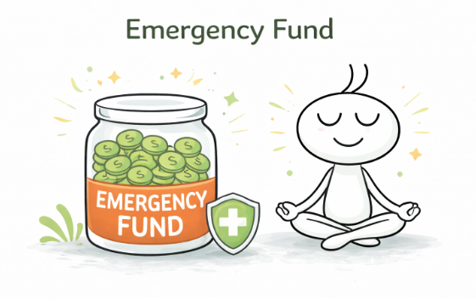
Chapter 6: Automate & Simplify
The best budget is the one that runs on autopilot.
Here’s how:
- Auto-transfer a fixed % of your income into savings/investments every month.
- Set reminders for bill payments and financial reviews.
- Use budgeting apps or an excel to track your progress.
- Review your money once a month, not every day.
Automation helps you stay consistent even on lazy or busy days.
You don’t need to control every rupee. You just need to direct it.
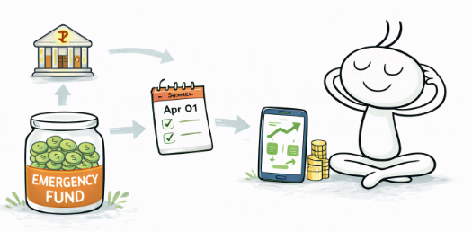
Chapter 7: Your Finances, Your Control
Budgeting isn’t about cutting down, it’s about choosing better.
It’s not a restriction; it’s freedom — the freedom to spend on what matters, to save for what’s important, and to live life on your terms.
Every decision in your budget is a reflection of your priorities and a quiet promise to your future self.
When you plan your money, you gain control.
And with control comes confidence, peace, and growth.
You’ve made it this far! Understanding how money moves, where it goes, and how to make it work for you.
That’s no small feat. You’ve built the foundation — awareness, clarity, and intent.
Now, it’s time to take the next step.
Because once you’ve learned to manage money, the real magic begins when you learn to grow it.
Budget wisely today, so you can invest boldly tomorrow.
